Hall ticket number : 2403a51436
Name : sateesh
Batch : 17 th
Branch : cse

Question 1 :
Scenario: In the domain of Healthcare, a company is facing a challenge related to data
structures with ai.
Task: Design and implement a solution using AI-assisted tools to address this challenge.
Include code, explanation of AI integration, and test results.
Deliverables: Source code, explanation, and output screenshots

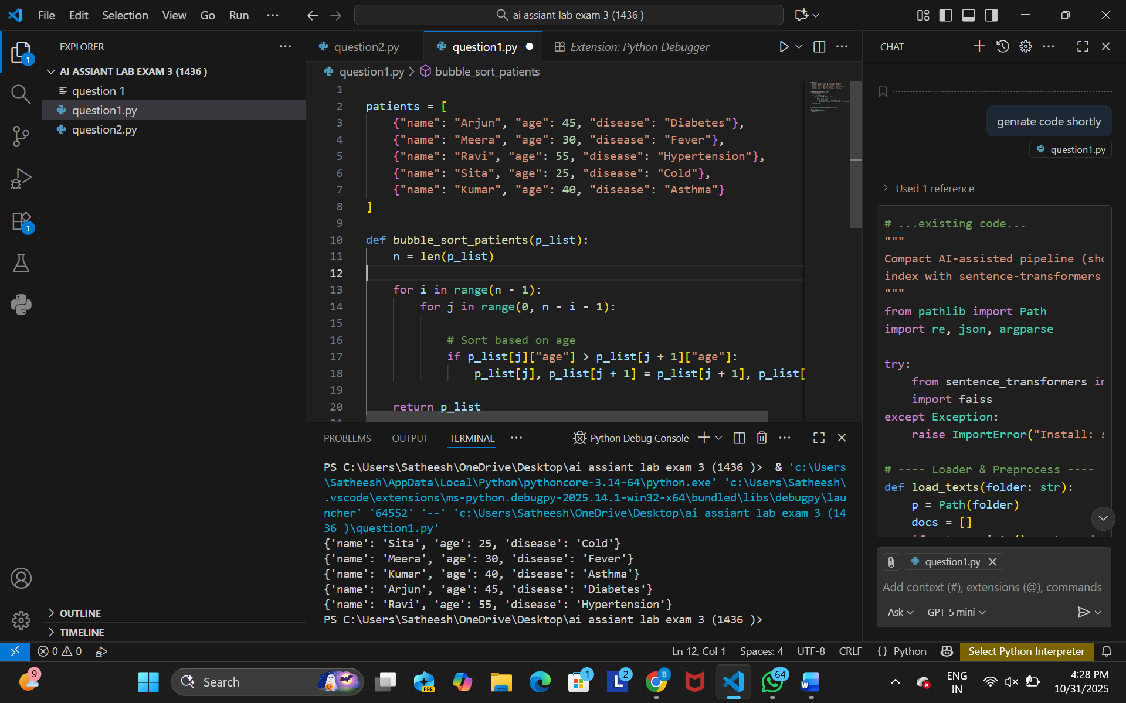

Question2 :
Scenario: In the domain of Agriculture, a company is facing a challenge related to code
refactoring.
Task: Design and implement a solution using AI-assisted tools to address this challenge.
Include code, explanation of AI integration, and test results.
Deliverables: Source code, explanation, and output screenshots.

Prompt :create a ai based solution for a health care company is facing changllenges in manging and processing complex data sturture such as paient records and clinical records

